**Agenda**

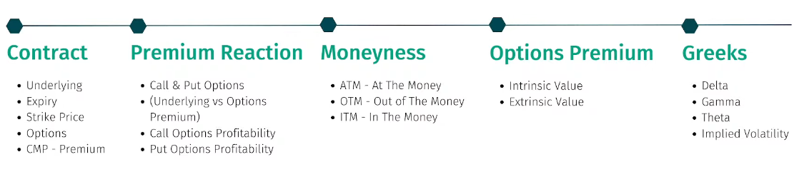

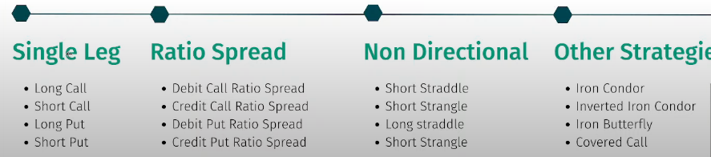

n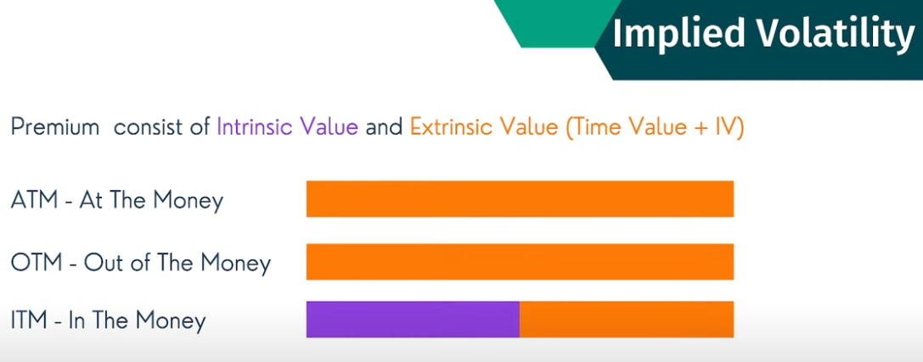

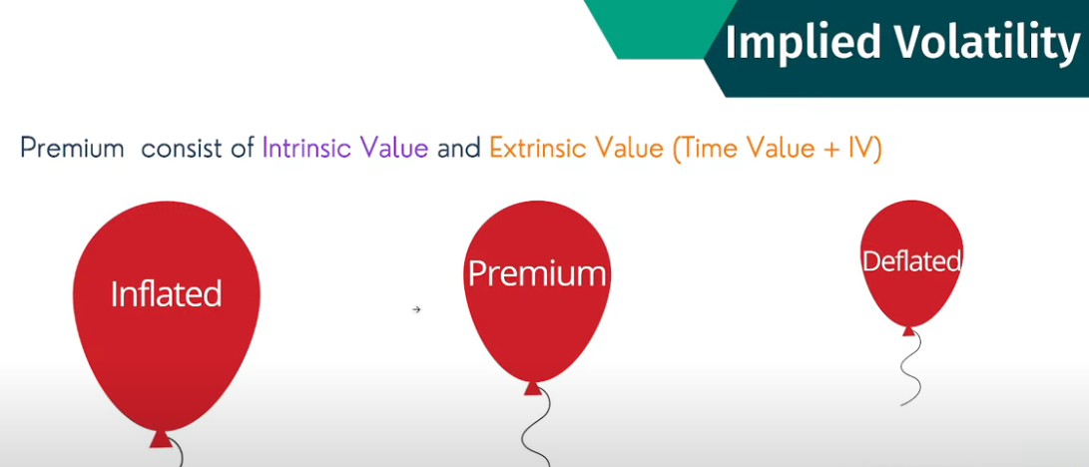 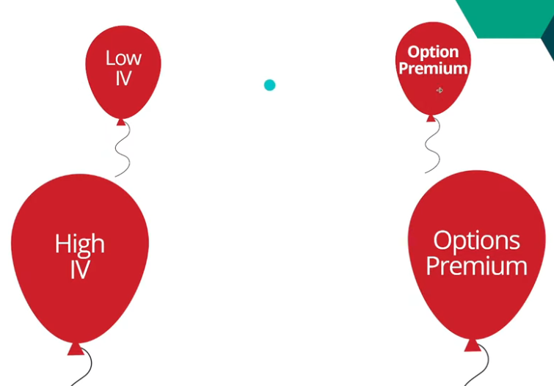

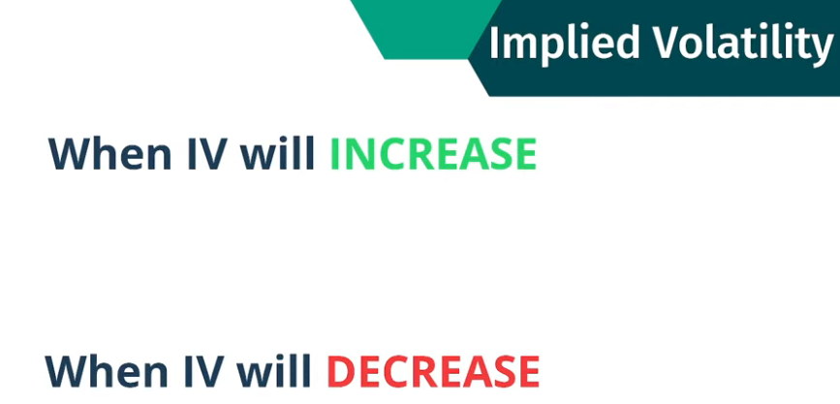

news based like rbi meet, war, budge, line of contact issues, fed event, scams due to uncertainty iv will increase.

once event or no issues, iv will decrease.

for option buying strategy, requirement is iv should increase, so that premium will increase.

If iv decreases, premium reduces and so loss may happen

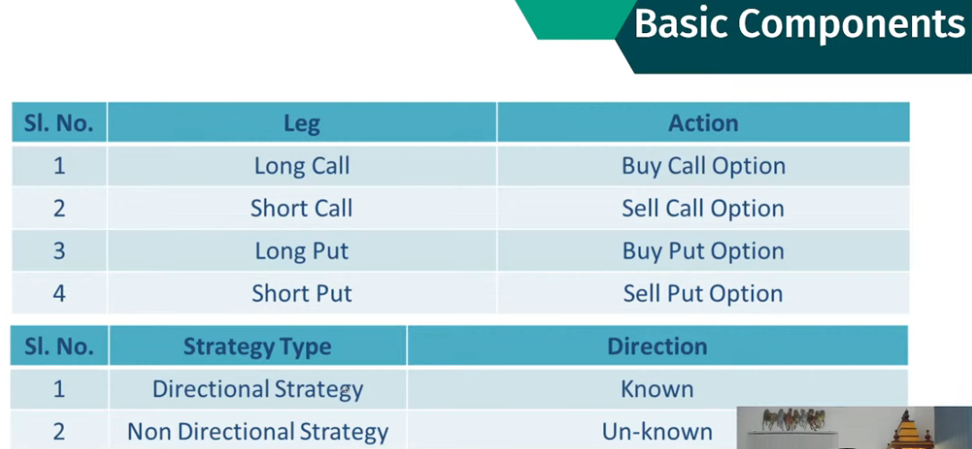

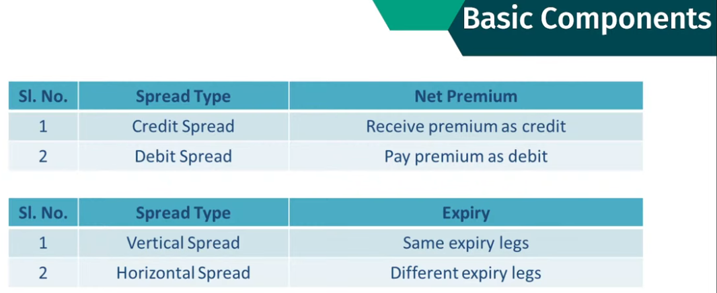

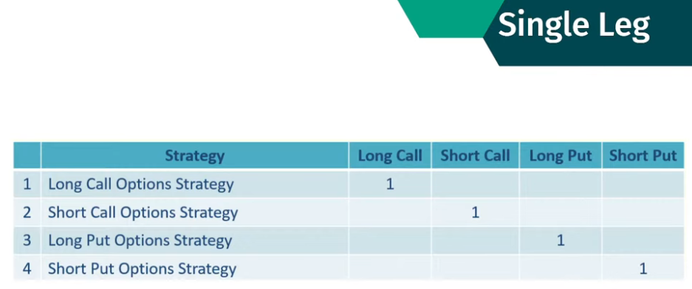

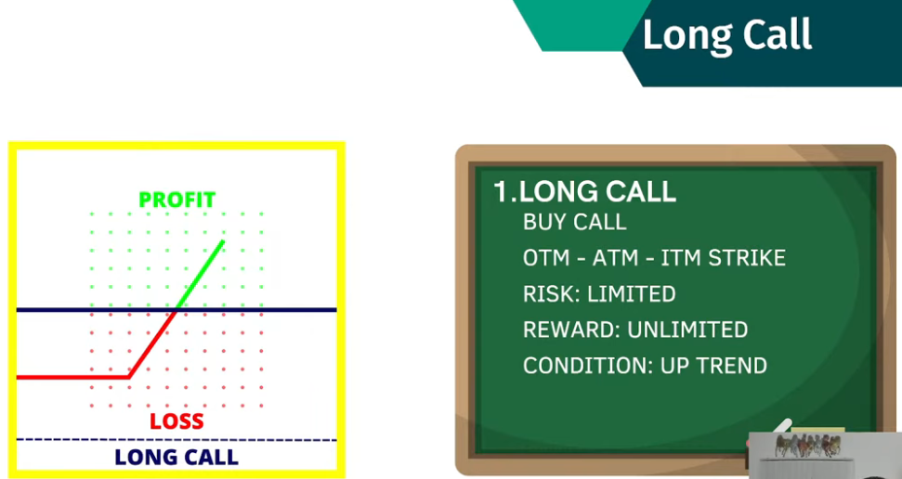

Recommended ITM: LESS decay, delta high, premium has intrinsic value, extrinsic value is less

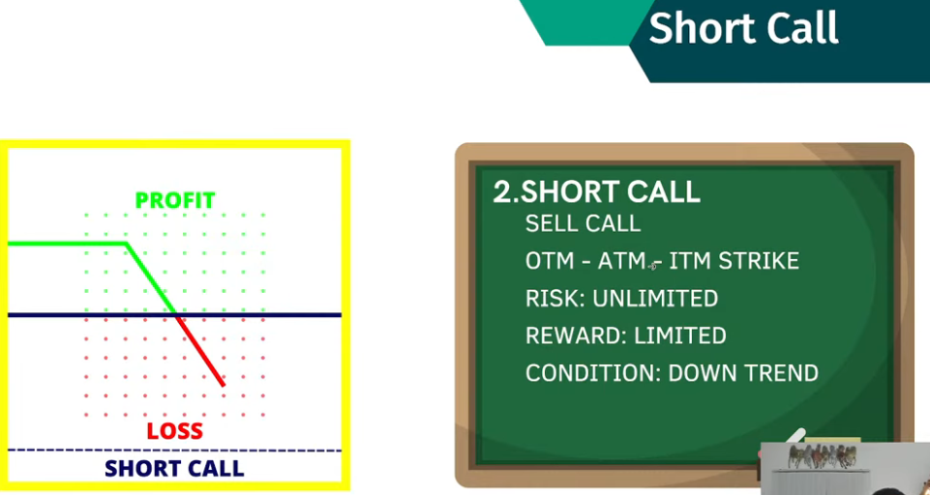

Recommended OTM AND ATM: HIGH decay, delta high, premium has no intrinsic value, extrinsic value is high

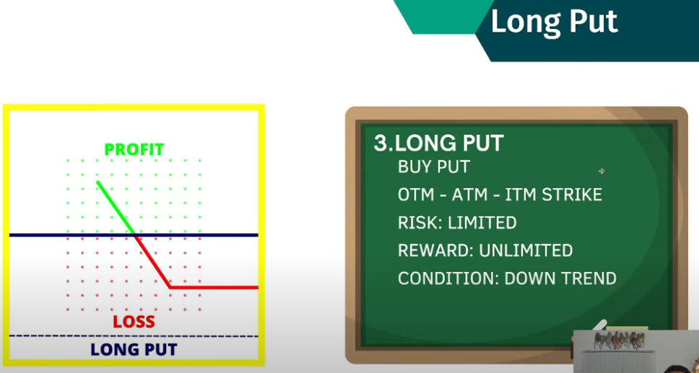

Recommended ITM: LESS decay, delta high, premium has intrinsic value, extrinsic value is less

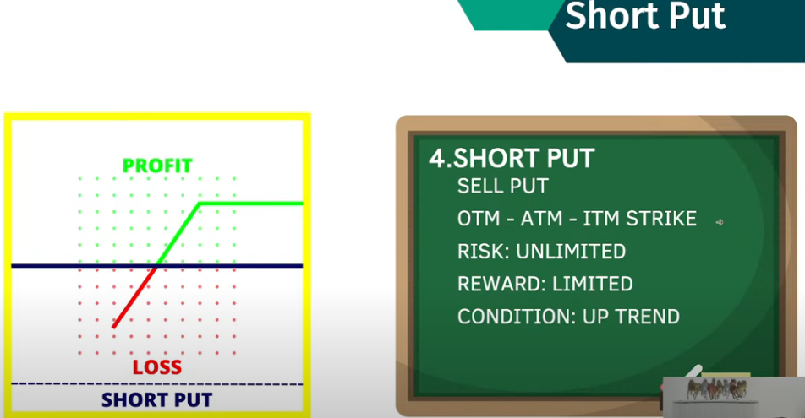

Recommended OTM AND ATM: HIGH decay, delta high, premium has no intrinsic value, extrinsic value is high

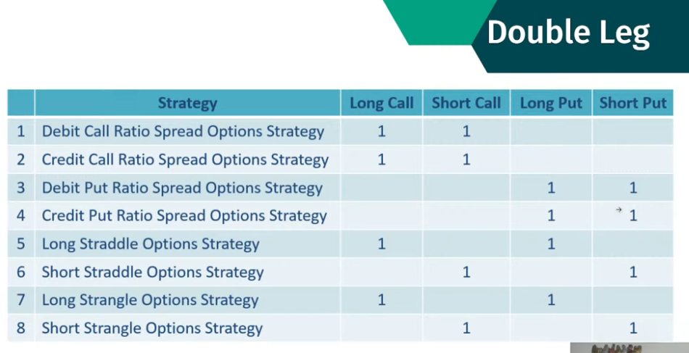

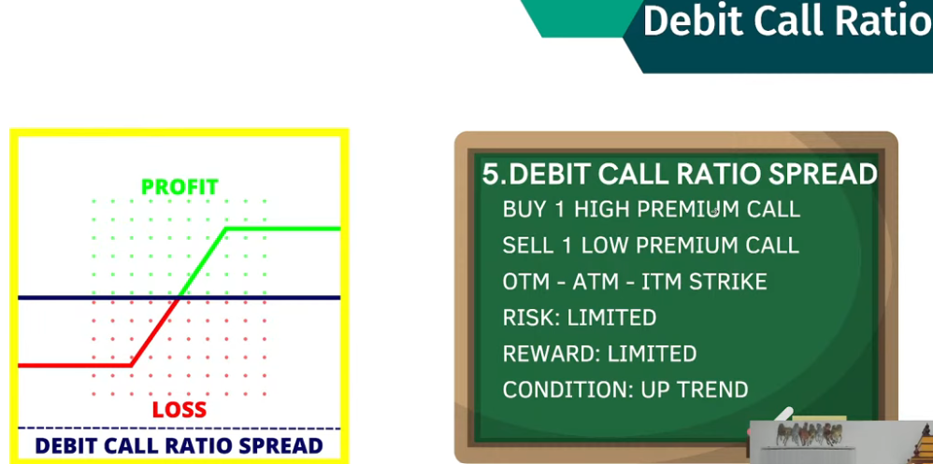 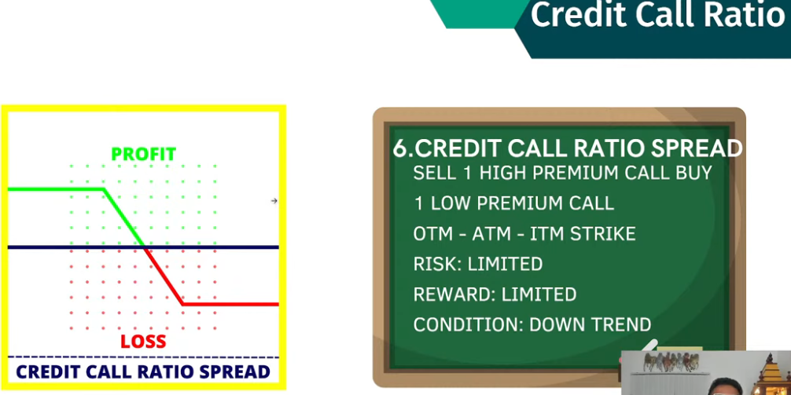

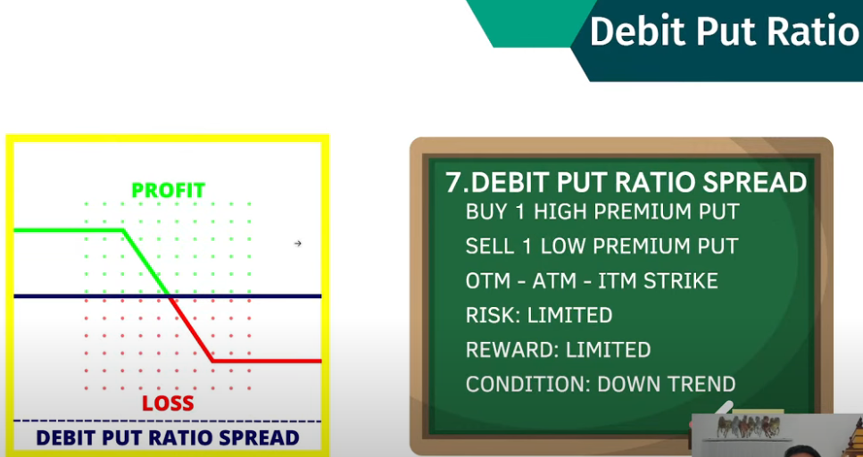 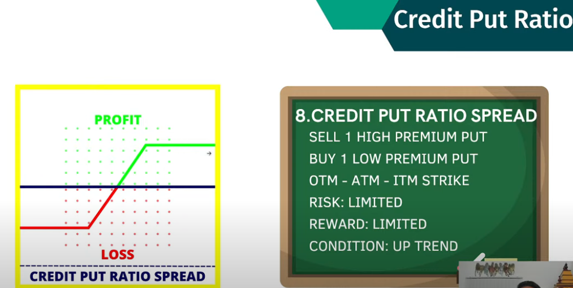

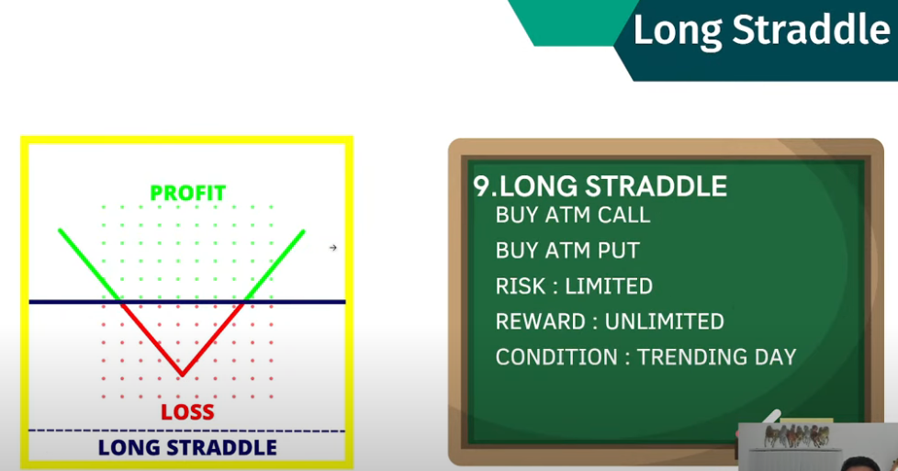 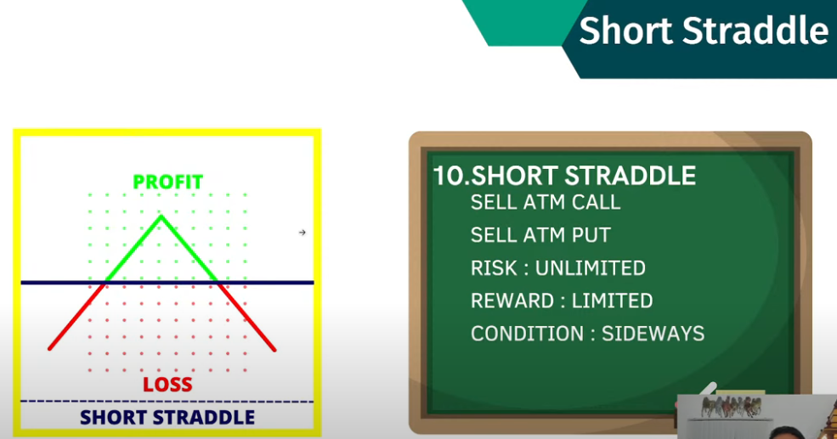

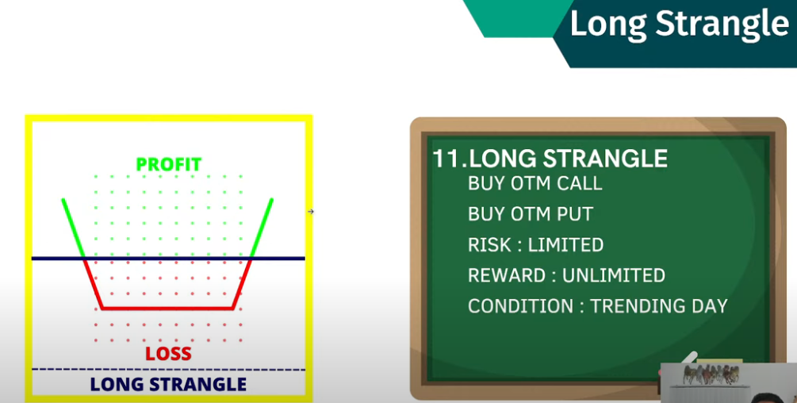 we can do on both OTM and ATM

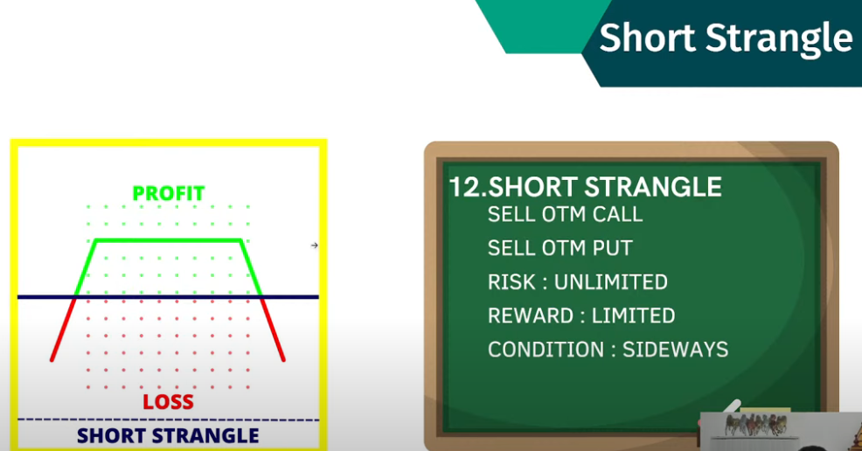

Say market is range bounded withing 39000 to 41000

Sell 39k put and sell 41k call. If market stays there as like predicted, on expiry both will be zero

